Review of Vertex Tower Application for Buckland
Fred Goldstein, Interisle Consulting Group, April 22, 2022
Vertex Towers LLC has filed an Application for Special Permit and Zoning Variance to build a Wireless Communications Facility overlooking 26 Martin Rd., Buckland. The proposed structure would be a monopole tower 150 feet tall, capable of carrying four carriers’ equipment centered at the 145, 135, 125 and 115 foot above ground levels. The primary purpose of the proposed tower is allow mobile carriers to fill in a coverage gap in the Rt. 112 corridor west of the tower, especially a gap between Rt. 2 to just south of the Ashfield town line, where coverage from another newly-proposed tower would begin.
Both Town and federal laws are potentially applicable. 47 U.S.C. 332(c)(7), part of the Telecommunications Act, protects the right of localities to enforce zoning codes for wireless towers but only to the extent that the zoning does “shall not prohibit or have the effect of prohibiting the provision of personal wireless services”. Nonetheless the application need not be granted as proposed if an adequate alternative is available, or if limiting its waivers do not substantially impair service.
The proposed height of the facility is intended to allow four providers, with the fourth provider, at the 115’ level, able to have adequate coverage, taking treetops into account. An antenna must be well clear of the local trees, as well as not be blocked by terrain. Some margin for tree growth is also usually included. Even if Vertex only has one customer currently lined up to use the tower, it would be imprudent to build one that did not have room for additional users, in order to minimize the need for more towers in the future. The tower site itself is more than 400 feet higher than Rt. 112 where it passes nearest, and over 1700 horizontal feet from the nearest point on Rt. 112 (Lower St.).

Terrain in the vicinity of the proposed facility
Route 112 runs north-northeast through a steep valley, essentially a hollow, with ridges rising on either side in a typical Appalachian pattern. The proposed facility’s site is on the western slope of the ridge (part of which is known as Mary Lyon Hill) that rises to over 1500 feet above sea level (ASL), versus an altitude of about 650 feet ASL on Lower St. to its west and below 600 feet ASL where Martin Rd. meets Lower St. The base of the proposed facility is at 1084 feet ASL and thus does not clear the hill to its east. (Mobile service to Shelburne Falls, east of the ridge, is already adequate.) Hills to the west of Rt. 112 rise to over 1500 and 1400 feet. Mobile coverage, which is based on approximate line-of-sight paths, is thus limited to a north-south pattern within the valley. Visibility of the tower may also be limited, as it will not rise above the top of the hill, but is likely to have a wooded backdrop when viewed from the west. Balloon tests will verify if this is in fact the case.

Existing and proposed facilities
The proposed facility is intended to allow carriers to fill in a gap in mobile device coverage because no existing towers reach into that area. Several existing towers in the approximate area were shown on the application, or are known to exist. Three towers currently serve the Shelburne Falls area and Rt. 2 corridor to the east. These are near Tower Road, Guy Manners Road, and Cooper Lane Road in the Town of Shelburne. A tower off of Spruce Corner Road in Ashfield has no carriers on it now; it is west of a ridge that blocks it from serving Ashfield Center or north. A tower on Mount Institute in Hawley (next to the Berkshire East ski area) serves much of the Rt. 2 corridor but not the subject Rt. 112 valley.
Two applications, both from Vertex companies, are pending nearby. One, off Ashfield Rd. in Conway just east of the Ashfield town line, fills in a gap between South Ashfield and Conway; it will not, if built, provide any service near Buckland. Another, just north of Ashfield’s Main St. area west of Baptist Corner Road, fills in a large gap in current coverage along Rt. 116 from Rt. 112 to South Ashfield and along parts of Rt. 112, but its coverage along Rt. 112 does not reach into Buckland due to the terrain. (It may, however, reach a few parts of Orcutt Hill Road and Clesson Brook Road in Buckland that have a southern exposure.) That tower’s coverage essentially dovetails with the proposed Buckland facility, to allow carriers to have continuous coverage along Rt. 112 from Rt. 116 to Rt. 2. These facilities thus appear to be part of an integrated plan by Vertex to efficiently fill in gaps in the northern hill towns area.

Coverage modeling
Coverage models were built based upon the proposed location and radio frequencies. Lower frequency signals are less sensitive to foliage blockage, and have greater coverage for the same power level. AT&T and Verizon typically build out coverage cells using frequencies in the 700 MHz band, so coverage models were built for a frequency of 750 MHz They may also use the 1900 MHz PCS band and the AWS-1 band that, using both 1700 and 2100 MHz, straddles it. Thus a 1900 MHz frequency was used for a second set of models. T-Mobile generally builds out its coverage on the 600 MHz band, whose behavior is very similar to 700 MHz.
The modeling software used for this study was RadioMobile. This derives coverage maps based upon publicly available digital elevation maps generated some years ago by the Space Shuttle (SRTM). It also uses public land-cover models to determine ground cover. Both are mapped to a one arc-second unit of area. Coverage is generally projected atop Open Street Map or Internet NationalMap, layered atop a topographically shaded map. (The relative density of these layers can be adjusted in RadioMobile.) This report makes use of the .png pictures generated by RadioMobile, which also produces .kml files enabling them to be viewed in Google Earth or other compatible software.
Coverage prediction maps were generated using two different antenna elevations above ground: 44 meters (145 feet ), representing the proposed appurtenance on the upper bay of the tower, and 35 meters (115 feet), the fourth potential bay down from the top.

Current coverage
Current coverage using only towers presently constructed shows a significant gap along Rt. 112, from roughly the intersection of Rt. 116 in Ashfield north to around the Purinton Road area near the Deerfield River. The northern part of gap is the main target of the proposed tower. Fig. 1 illustrates existing coverage, with the proposed tower and two other pending proposals, in Ashfield and Conway, also shown labeled in blue. Three towers in Shelburne and one in Hawley are shown and none cover the targeted valley. Route 2 and the Shelburne Falls village area are shown to be well covered.

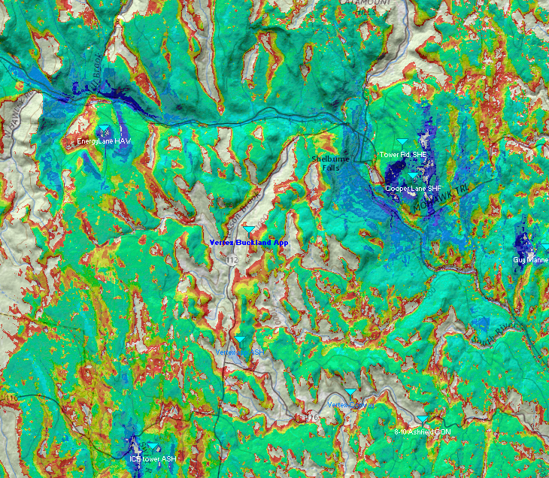
Figure 1. Coverage prediction with existing towers. Proposed towers are labeled in blue. Signal strength is indicated by color; green and blue are strongest, while red is marginal at best and orange to yellow represent weaker signals.
Adding the planned Ashfield and Conway towers’ coverage to the existing map shows that only one major gap remains along major roads in the vicinity, on Rt. 112 from a bit south of the Buckland line north almost to Rt. 2 in Buckland.
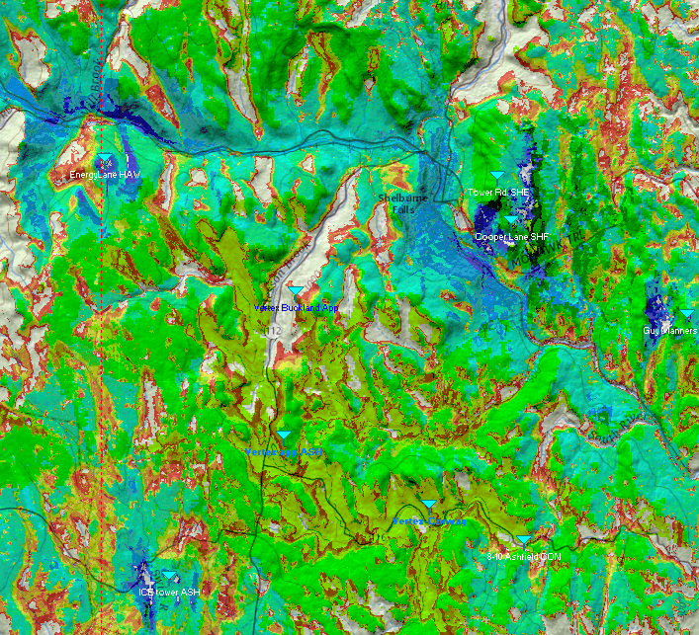
Figure 2 Existing coverage overlaid with likely coverage from proposed towers in Ashfield and Conway (in green).
The proposed tower should provide coverage in a largely north-south pattern along the Rt. 112 corridor and Clesson Brook valley, from northern Ashfield to East Charlemont. It thus directly addresses the major gap in service remaining after the two other nearby planned towers go into service. The location is moderately critical in that it is at a point that sees to both the south and northeast, where the valley and road bend around Mary Lyon Hill. As proposed, the tower’s highest berth would hold antennas centered at the 145 foot level, whose predicted coverage is in Figure 3.
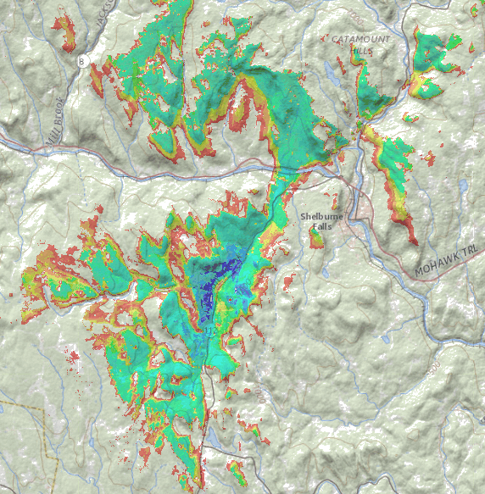
Figure 3 Coverage of the proposed tower from the 145-foot level at 700 MHz.
If four carriers locate on the tower, the fourth would be at the 115-foot level. Of course if the tower is only approved at a lower height, then this height would be applicable to an earlier user. Coverage at the 115-foot level looks basically similar at a high level though differs in some detail at low points. Less than 10% of total coverage is lost but attention should be paid to one spot along Rt. 112 near the tower itself.
At the lower elevation, coverage is degraded on a stretch of Upper St./Rt. 112 less than a mile long just north of where Upper St. meets Lower St. That is where the hill itself rises steeply on the eastern side of the road and becomes an obstacle impeding the view of the tower.

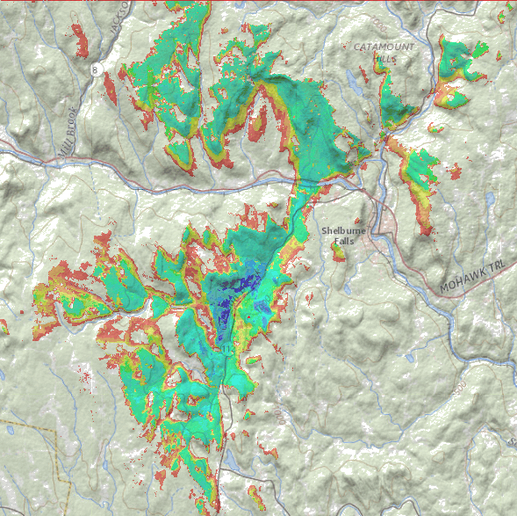
Figure 4 Coverage of the proposed tower from the 115-foot level on 700 MHz.

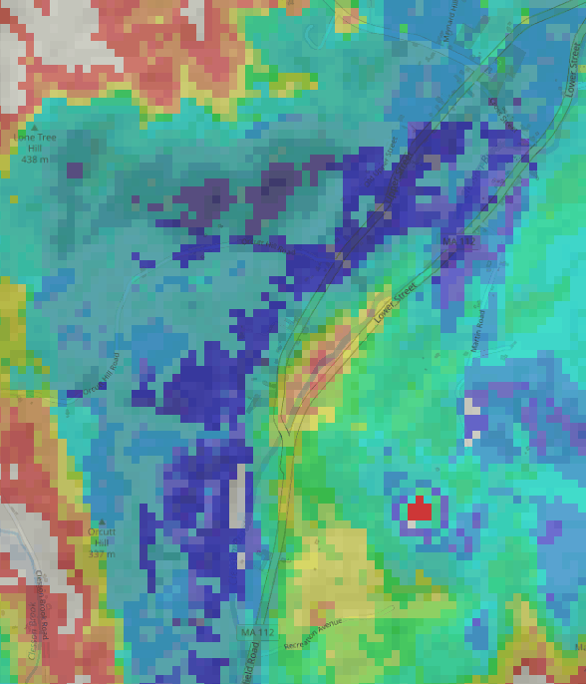
Figure 5 Coverage detail at 145 feet
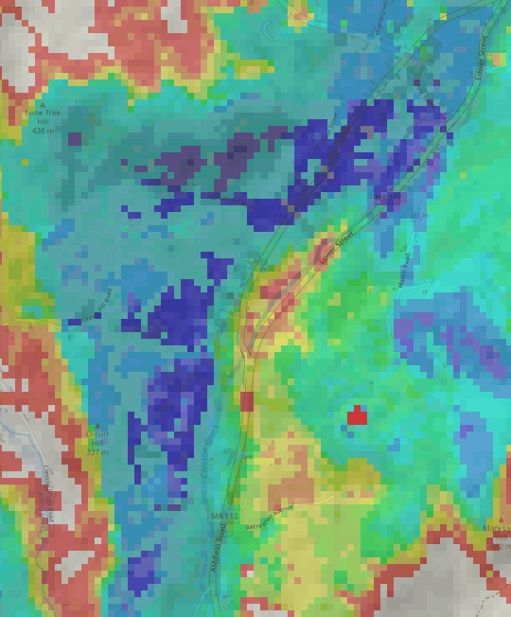
Figure 6 Coverage detail at 115 feet

These detailed pictures show that at the lower elevation, the poorly-served stretch of Rt. 112 is larger, extending somewhat south of Upper Rd. However, it is still under a mile and mobile signals are not likely to be lost. At any lower elevation, however, service in that stretch is likely to be significantly worse. At 95 feet, poor signal coverage along Rt. 112 extends almost south to the intersection with Recreation Avenue and is also poorer in the weak-signal area north of the Upper St. intersection.

Alternative sites in application
The application lists six alternative sites that were considered. These were spot-checked in the model to verify whether the application properly characterized them.
Alternative A is well north of the proposed site and west of Rt. 112. As noted in the application, it would not satisfy the coverage objective; only a portion of the gap on Rt. 112 would actually be filled from the 145-foot level.
Alternative B, east of Alternative A, was rejected in part because of inaccessibility. Its coverage would have been better than Alternative A’s but still leave modest gaps in coverage near the intersection of Upper and 112 and also closer to Ashfield.
Alternative C, off Avery Road on Lone Tree Hill, was rejected in part because of inaccessibility. Its coverage would have left a significant gap in the middle of the current gap area and at its northern end.
Alternative D, off Old Upper St, was rejected in part because it would be much more visible to abutters. Its coverage along the mid-stretch of Rt. 112 would be adequate. Vertex says that it would “not have connected to the Ashfield location” and when combined with the Baptist Corner Road planned site in Ashfield, a small gap in coverage, or at best marginal coverage, remains in the northern end of Ashfield.
Alternative E, off Fred Laird Road, is north of the ridge that the proposed site is on and its coverage would only have included the northern part of the gap on Rt. 116.
Alternative F is on an adjoining property to the proposed site, a short distance away. Its coverage would have been only slightly inferior to the proposed site’s. It was deemed inferior due to the likelihood of wetlands problems as well as the likelihood of being more visible. However, the Commonweatlth’s GIS data shows wetlands (Title 5 buffers) on the adjoining property at 253 Ashfield, not on the undeveloped lot (under the same ownership) where the tower would be sited.
The Transfer Station was also suggested as an alternative site. This would not be satisfactory because its coverage does not reach northward past the point where the road turns north-northeast, near the Upper St. intersection, as the western end of Mary Lyon Hill is in the way. It would also not cover most of Upper St., which would be behind that hill.
The general vicinity of the proposed tower is thus an ideal location because of its ability to serve two unserved and otherwise-separate sections of Rt.112. While Alternative F is technically satisfactory from a coverage point of view, its access problems led to preferring the proposed site.

Checklist
These are bylaw items that must be met.

10-3 (b) Must show it's necessary
The gap analysis demonstrates a need for an additional tower to cover a large gap along Rt. 112.

10-4 Location is in compliance with FCC/FAA requirements
The application includes a TOWAIR determination on page 55. Towers over 200 feet or, if within 8 km of an airport, at certain lower heights, require registration and may require lighting. This tower is below 200 feet and not near an airport.

10-5 a) Minimum height necessary
If there are to be four collocators, the application is at the minimum height that is likely to be effective. If fewer users are anticipated, a slightly shorter tower may be satisfactory.
10-5 b) The Planning Board must produce a Finding that there are no existing facilities to do the job
No existing facilities are known that serve the primary intended area.

10-8 No FAA lighting required
The TOWAIR determination indicates that no lighting is required.

10-13 RFR standards
This is a matter of federal jurisdiction and the proposed facility meets the requirement by a factor of more than 400 even if four collocators are using it. Elevation keeps the highest radiation well above the ground. Typical cellular antennas have a half-power elevation beam width of about 8 degrees and are down-tilted at 4-6 degrees. Power decreases per the inverse square law, one quarter the power density as the distance doubles. By the time the main signal “pancake” reaches ground level it is some distance from the tower and far below federal safety standards.

